Subdomain Takeover
Beacon Labs - Lab Setup

Step 1: Register Domain

- Create a Route53 account and register an arbitrary domain name in the Route53 dashboard

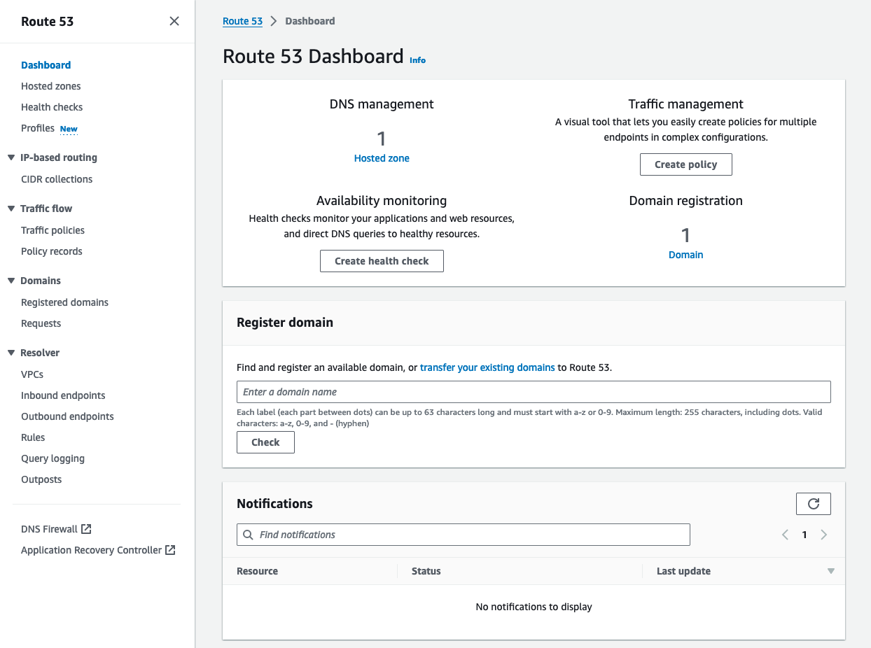

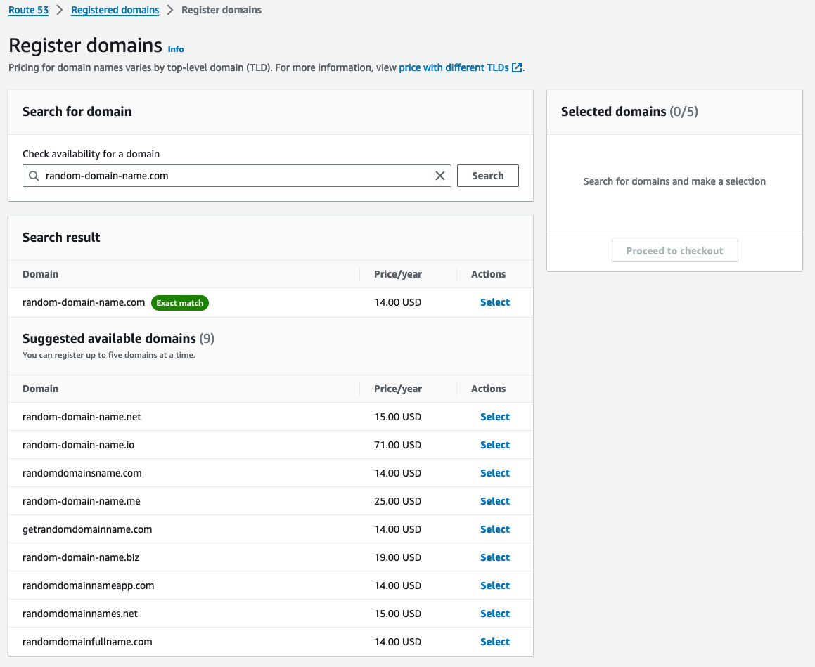

Step 2: Deploy Dummy Domain

- Navigate to the AWS Amplify and deploy the test.html file
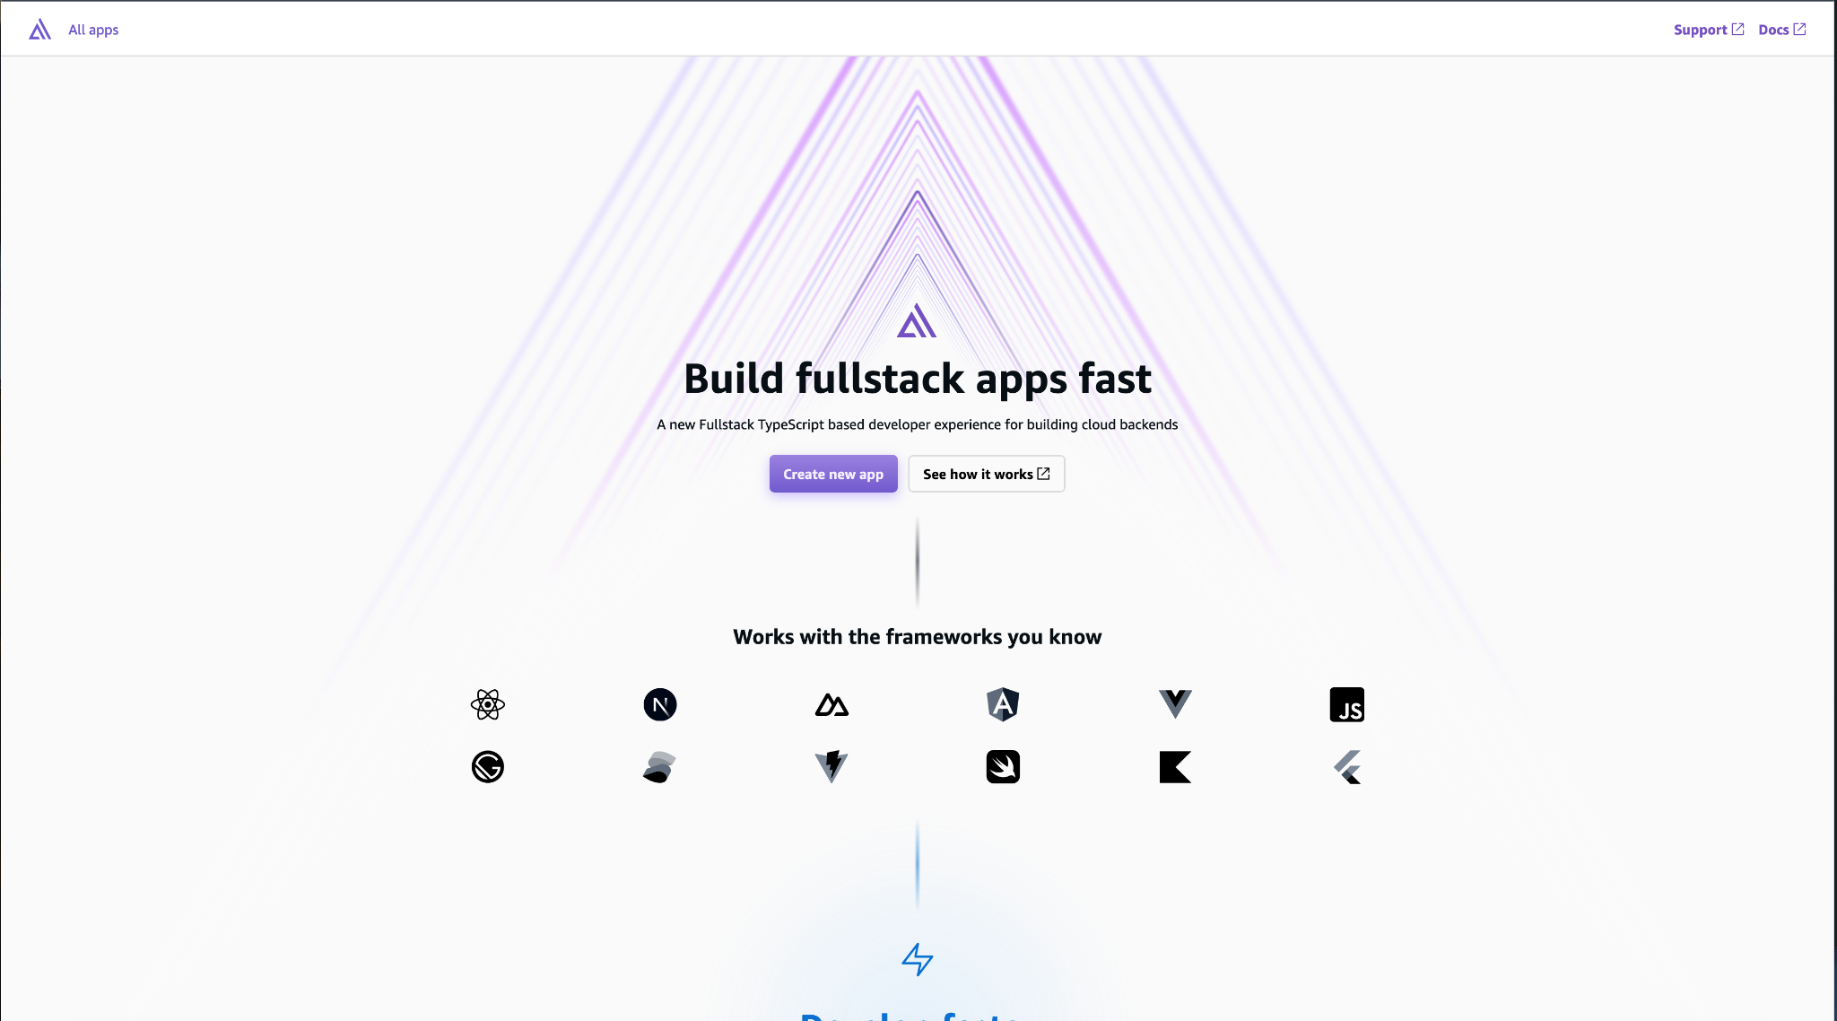
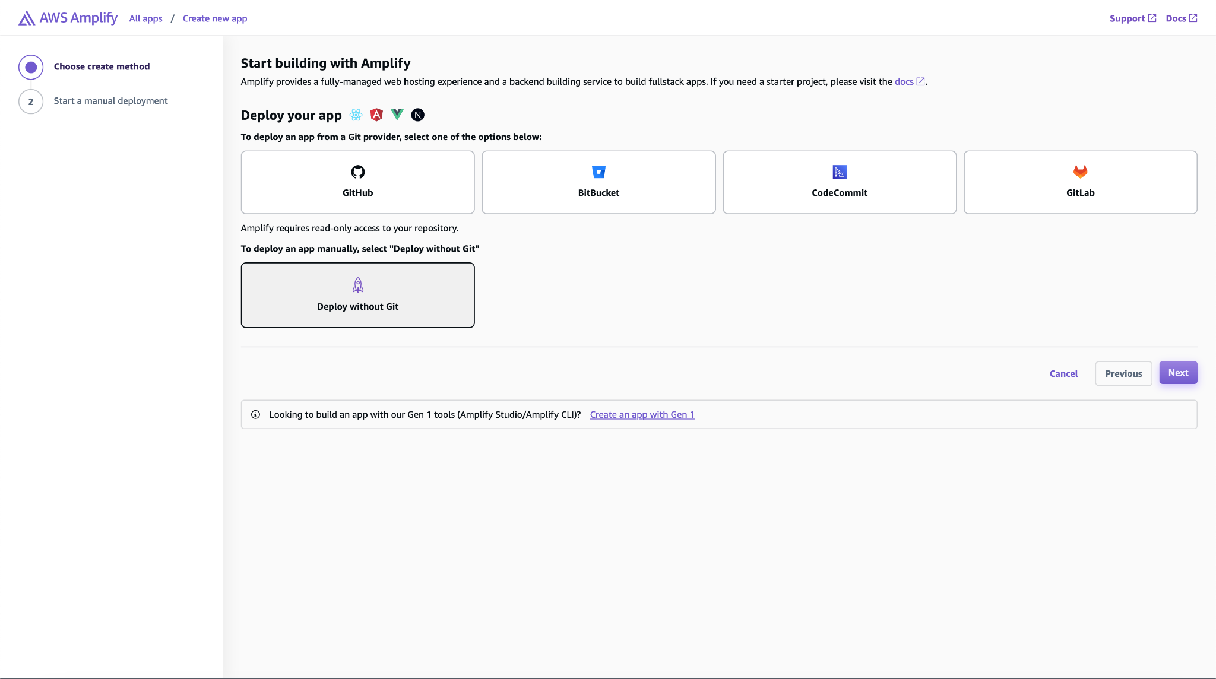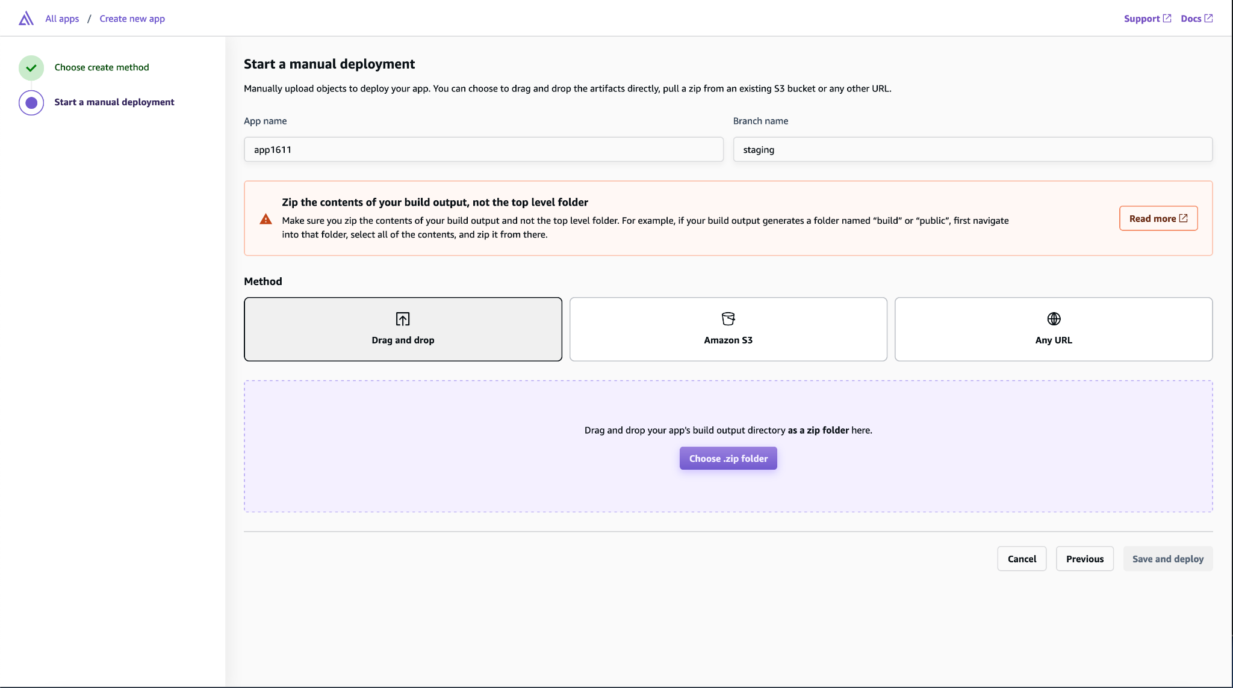
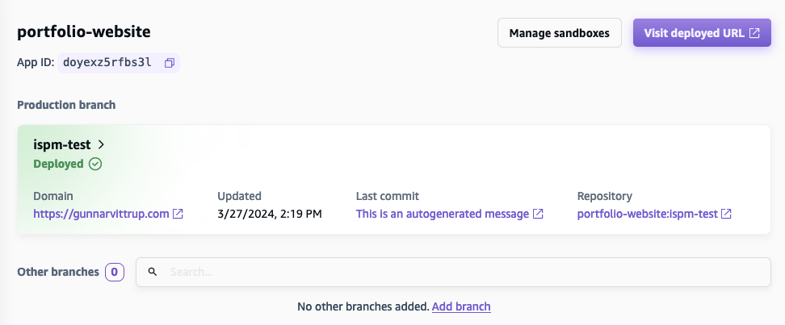
- Assign the domain name you created in the previous step to this resource
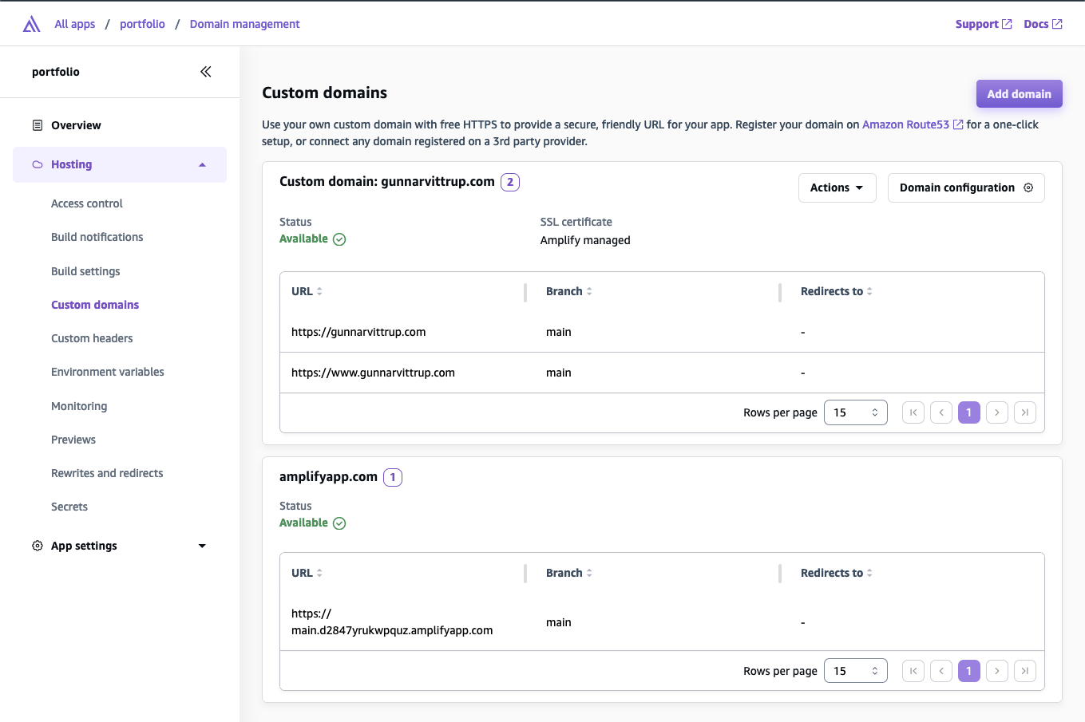
- Validate that the domain is reachable

Step 3: Create Empty Records

- Navigate to the ‘Hosted Zones’ section of Route53, and select the domain name you purchased
- Create a series of ‘empty’ CNAME records (whatever size suits your class - ideally 2x class size) that reference legitimate third-party resources.
  - Select ‘Create Record’
  - For each record, ‘Record Name’ is the name of the arbitrary subdomain followed by the domain you purchased, , i.e. subdomain.domain.com. The ‘Value’ field corresponds to the empty third-party resource you are creating. For the ‘TTL (seconds)’ field, set the value to 86400, as this is the standard value for CNAME records. The list below helps to identify how to create the empty record per each service.
    - GitHub uses subdomain.github.io
    - Surge uses subdomain.surge.sh
  - Note: the subdomain needs to be the same in both your domain’s subdomain and the name of the third party resource

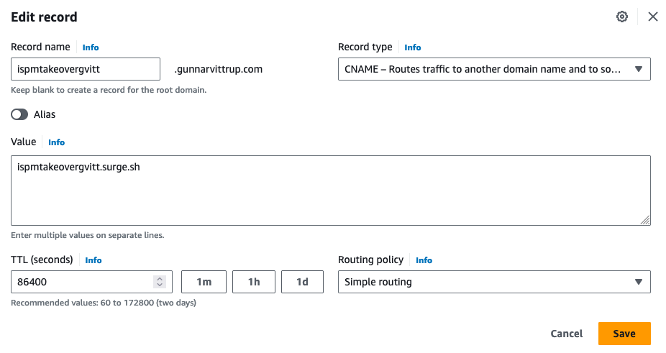

Step 4: Create Text Document

- Next step is to create a domains.txt file that contains the apex root domain your-domain.com followed by the list of all subdomains you created in the previous step subdomain.your-domain.com. Package this document in the project folders to provide to your students. 